Lab Assignment 1-2 Linux Installation and Usage Linux+ and LPIC-1

- Log in to Linux and run the command below and show your results:

ls –al
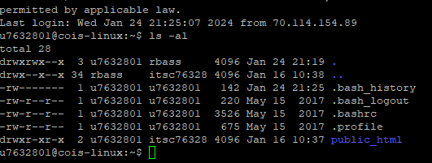

- Run the command “date” and show the results:
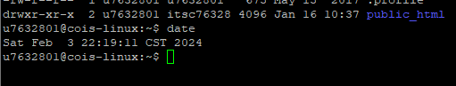

- Run the command “cal” and show the results:
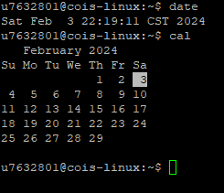

- Now run the command below and show the results:
uname –a

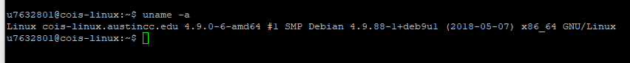
- Run the command: “ id” and show the results:
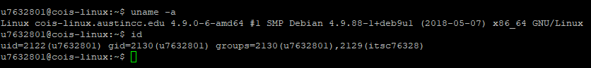

- Run the following commands and show the results:

echo My Shell is SHELL
echo My Shell is $SHELL
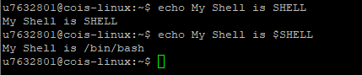

- Run the “man whoami” command and show the results:
in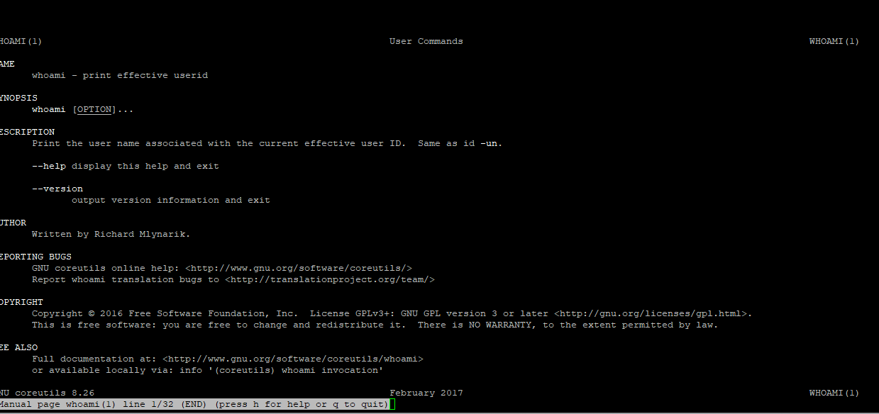

- Now run the command “info whoami” and show the results:
qqwq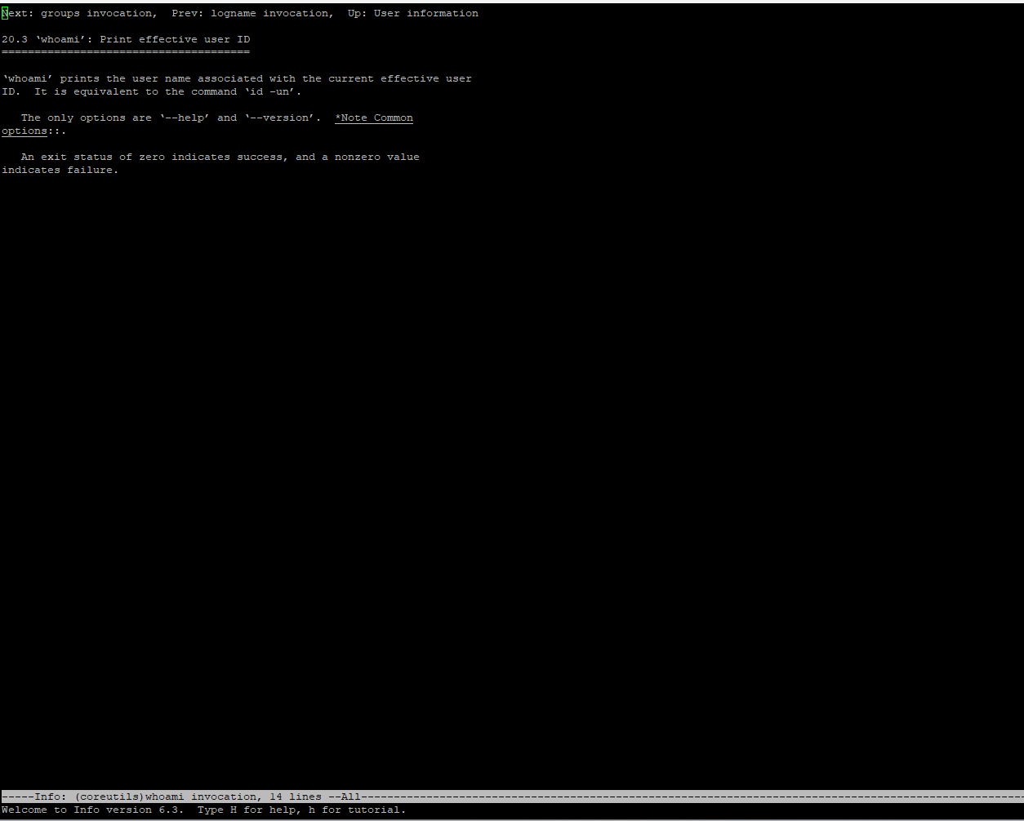

- Run the command “man –k usb” and show the results:
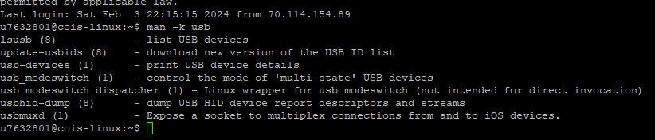

- Finally run the following commands and show the results:

ls
ls –a




